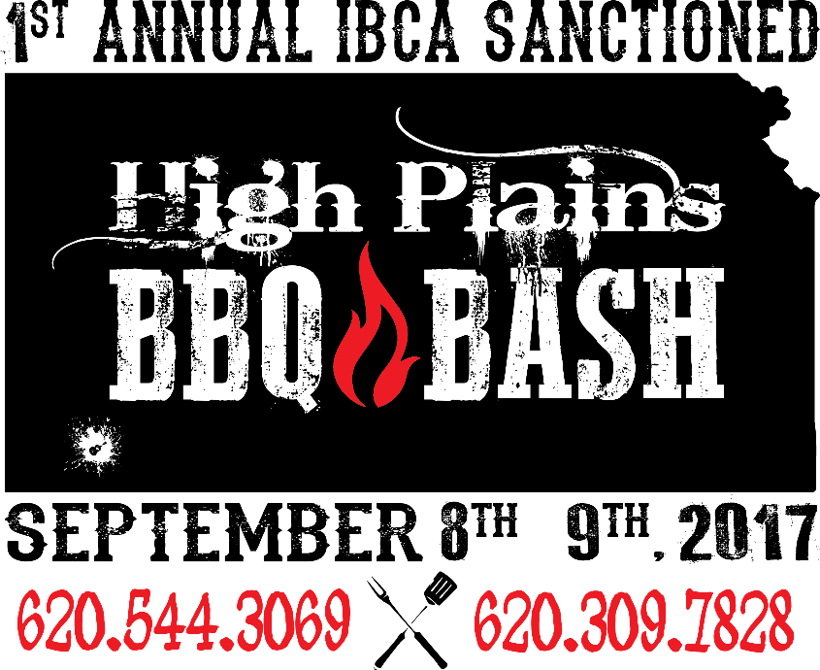
September 8TH AND 9th, 2017
Hugoton, Kansas
Please Print/Type
Head Cook________________________________________________________________
Team Name_______________________________________________________________
Mailing Address_________________________City__________________ST_____Zip________
Phone______________________ email_______________________________________
Entering:
3 Meat (Chicken, Brisket and Ribs) _____ ($125) Jackpot Beans _____ ($25)

Jackpots will payout in Full!!
Please make all checks payable to High Plains Music Fest.
Mail this form along with payment to:
Jan Leonard
701 W City Limits
Hugoton, KS 67951

Payment received by: ______________________________________________________

*We the members of the above named team, acknowledge and understand that we are responsible for our own actions during or related to the participation at The High Plains BBQ Bash Cook Off, and accordingly hereby RELEASE THE HIGH PLAINS BBQ BASH, ALL ITS MEMBERS AND VOLUNTEERS FROM LIABILITY (including damages, costs, and attorney’s fees) for any and all accidents or injuries whether to person or property, which may occur as a result of your participation in the High Plains BBQ Bash Off, including accidents or injuries caused by or related to the consumption of alcohol.
I HAVE READ THE RULES AND REGULATIONS OF THE HIGH PLAINS BBQ BASH COOK-OFF AND AGREE TO ABIDE BY THEM. ANY VIOLATION OF THE RULES AND REGULATIONS WILL CAUSE FORFEITURE OF ANY AND ALL PRIVILEGES AND OR PREMIUMS WON.*
Head Cook Signature: ________________________________________________________
IF YOU HAVE ANY QUESTIONS PLEASE CONTACT
Jan Leonard @ (620) 544-3069 or Alisha Owens @ (620) 309-7828
For Cook-Off updates and further information, please visit
www.highplainsmusicfest.us
LIKE & FOLLOW HIGH PLAINS MUSIC FEST ON FACEBOOK!

